A Mini Project Report
On
AQUAS
Submitted in partial fulfillment of the
Requirements for the award of degree of
Bachelor of Technology
In
Computer Science and Engineering
By
Pattan Sharuq Khan,
(14H61A05B9)
Reno Joseph,
(14H61A05A7)
Peddi Akhil,
(14H61A0584)
Under the Guidance of
P. Raja Sekhar Reddy
Asst. Professor

Department of Computer Science and Engineering
ANURAG GROUP OF INSTITUTIONS
(Formerly CVSR College of Engineering)
(An Autonomous Institution, Approved by AICTE and NBA Accredited)
Venkatapur (V), Ghatkesar (M), RR Dist., T.S-500088
(2014-2018)



CERTIFICATE

This is to certify that the project entitled “AQUAS” being submitted by Pattan Sharuq Khan bearing the Hall Ticket number 14H61A05B9, Reno Joseph Stephen bearing the Hall Ticket number 14H61A05A7 and Peddi Akhil bearing the Hall Ticket number 14H61A0584 in partial fulfillment of the requirements for the award of the degree of the Bachelor of Technology in Computer Science and Engineering to Anurag Group of Institutions (Formerly CVSR College of Engineering) is a record of bonafide work carried out by them under my guidance and supervision from July 2017 to October 2017.
The results presented in this project have been verified and found to be satisfactory. The results embodied in this project report have not been submitted to any other University for the award of any other degree or diploma.

Internal Guide External Examiner
P. Raja Sekhar Reddy
Asst. Professor

Project Coordinator
Pallam Ravi
Asst. Professor

Dr. G. Vishnu Moorthy,
Deputy Director and Head, Dept. of CSE

ACKNOWLEDGEMENT

It is our privilege and pleasure to express profound sense of respect, gratitude and indebtedness to our guide P. Raja Sekhar Reddy Asst. Professor, Dept. of Computer Science and Engineering, Anurag Group of Institutions (Formerly CVSR College of Engineering), for his indefatigable inspiration, guidance, cogent discussion, constructive criticisms and encouragement, suggestions, motivation and co-operation throughout this dissertation work and for the successful completion of the work.

We express our sincere gratitude to Dr. G.Vishnu Moorthy, Deputy Director & Head, Department of Computer Science and Engineering, Anurag Group of Institutions (Formerly CVSR College of Engineering), for his suggestions, motivations and co-operation for the successful completion of the work.
We extend our sincere thanks to Dr. K.S.Rao, Director, Dr. V.Vijaya Kumar, Dean, Dept. of CSE & IT, Anurag Group of Institutions (Formerly CVSR College of Engineering), Venkatapur (V), Ghatkesar (M), Ranga Reddy (Dist), for their encouragement.

Pattan Sharuq Khan-14H61A05B9
Reno Joseph Stephen-14H61A05A7
Peddi Akhil-14H61A0584

DECLARATION

We hereby declare that the project work entitled “AQUAS” submitted to the Anurag Group of Institutions (Formerly CVSR College of Engineering) in partial fulfillment of the requirements for the award of the degree of Bachelor of Technology (B. Tech) in Computer Science and Engineering is a record of an original work done by us under the guidance of P .Raja Sekhar Reddy Asst. Professor, and this project work have not been submitted to any other university for the award of any other degree or diploma.

Sharuq Khan (14H61A05B9),
Reno Joseph Stephen (14H61A05A7),
Peddi Akhil (14H61A0584).

Date:

ABSTRACT

An online shopping system that permits a customer to submit online orders for items and/or services from a store that serves both walk-in customers and online customers. The system accepts the customer's submission of a purchase order for the item in response to a time of submission being before the order cutoff time. The online shopping system does not settle with a credit supplier of the customer until the item selected by the customer is picked from inventory but before it is delivered. Therefore, the customer can go online and make changes to the order. In addition, available service windows are presented to the customer as a function of customer selected order and service types; and further, the order picking is assigned in accordance with a picker's preference.
Sometimes it may happen that the Aquarium tank may break, or the fishes may die might be due to environmental conditions or falling off. The main objective of this web page is to provide the product home delivered to the required or mentioned address. By communicating with the customer through the E-Commerce page the delivering of the products are done.

Key Terms: Home Delivery, Aquarium Tanks, Fishes, Fish Food, Services, Registration, Payment

The customer may get the AQUAS products or the service after registering with the website. Once the registration is completed the customer can request the service. After getting the products delivered the customer will be provided with the guidance of usage and environmental conditions for the fishes to survive This website apart from the above service will also provide the monthly services.

Contents
S.no Page no.
1. Introduction..................................................................................................................07
1.1 Scope……………………………………………………………………....……..07
1.2 Objective of the project………………………………………………..………....08
1.3 Existing System……………………………………………………..…….……...08
1.4 Proposed System………………………………………………...………...……..08
2. Technologies used.........................................................................................................08
3. Design............................................................................................................................09
3.1 Activity flow of the system……………………………………………..……......09
3.2 Actors…………………………………………………………………….……....11
3.3 Modules…………………………………………………………………….….....11
3.3.1 Admin Module……………………………………………………….….....14
3.3.2 User Module………………………………………………………….….....14
4. Implementation..............................................................................................................17
4.1 Source code structure.............................................................................................17
4.1.1 Folders...........................................................................................................17
4.1.2 Files...............................................................................................................17
5. Database Design............................................................................................................36
6. Test Cases…………………………………………………………………..…..……..47
7. Screenshots....................................................................................................................48
8. Deployment...................................................................................................................54
9. Conclusion and Further Enhancements.........................................................................57

1. Introduction

Ornamental fishes are the third most common group of pets in the homes today. The 2011–2012 survey of the American Pet Products Manufacturers Association reported that 62% of U.S. households (73 million homes) own a pet. Of these, 17% own ornamental aquarium fishes, totaling 73 million homes with more than 151.1 million freshwaters and 8.61 million saltwater fishes. During the past decade, fishes were one of the fastest growing categories of pets in the U.S., increasing in ownership by more than 20% over the previous decade. Ornamental fishes sold in the country are both bred domestically and imported from abroad. More than 90% of live non-domesticated wildlife imported during the period 2000–2006 was freshwater and marine ornamental fishes, originating largely from Southeast Asia, and totaling 1.1 billion individuals. On average, 18 thousand shipments and 187 million live aquarium fishes were imported annually, 99% of which were intended for commercial sale in the pet industry.
AQUAS is an E-commerce website where the customers can order Aquarium products rightly from their home. The tanks are fragile which makes it difficult for the customer for transportation and the fishes is not easily prone to environmental conditions which decreases their life span. This web page’s objective is to provide the required products related to the Aquatic life. Sometimes people may be busy and may not find the time to get the fish supplements. AQUAS also provides doorstep services for the customers where the maintenance team goes to the customers home, services the tank. At the time of request for the service, the customer need to register and give the exact address for servicing. Payments can be done either through payment gateway or cash on delivery. This website makes it easy for the customers for purchasing and servicing which is available 24*7.

1.1 Scope:
Aquas is a website created with an aim to help those people who are interested in online shopping. The advancement in technology is changing day by day so now no one is interested to go to the shops and buy products everyone is thinking about shopping online. The website provides scope for online shopping for aquariums and aquarium products like fishes, lights, heaters etc.,

1.2 Objective of the Project:
This Project paves the way to accomplish an easier way for the people to shop different varieties of aquarium products. The project has doorstep deliveries and doorstep services which attracts the people who are not interested to shop in stores.
1.3 Existing System:
In the existing systems, the user is not provided with doorstep services.
There is no website which is related to only aquariums and aquarium projects. The existing systems are Amazon, Petsmart etc.,
1.6 Proposed System:
Through this project, we suggest an easy, user-friendly and convenient way of displaying all aquarium and aquarium products. In this project we take the problems that user face in maintaining aquariums and we provide doorstep solutions if needed.

2.Technologies Used
1. Client-side Technologies : HTML5 ,CSS, JavaScript, Bootstrap ,Ajax
2. Server-side Technologies : PHP
3. Database : MySQL
4. Operating System : Windows 7,8,10
5. Software’s : WAMP Server

- Design
3.1 Activity Diagram:
As shown in the activity diagram, the activity starts with the customer registering with the website. After registering, the next activity is, the user will log in and request for the service. The service can be either Doorstep Service or Home delivery. Doorstep Service is preferred when the customer or user wants their aquarium to be serviced at their doorstep. Aquarium fishes are generally used or preferred as a pet. In the next activity, the user or customer is given a task of exploring the website through which the customer can order or search for a product. Then the prices are checked if it is satisfactory the product is added to the cart. If the customer is willing to buy, then he can check out by providing the address and phone number for delivery. Then the order is placed. The payment process can be done either by payment gateway or cash on delivery. Service requests are made by providing the address where it is attended within two days.

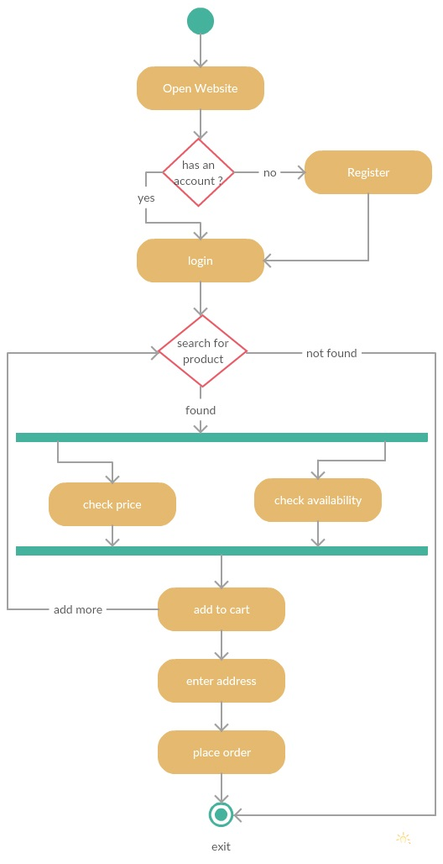

Figure 1: Activity Diagram for AQUAS.

3.2 Actors and Description:
The actors in this project are:
- Web Customer
- Admin
- Service
Description:

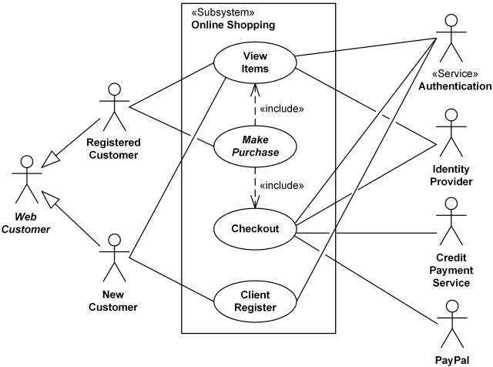
Figure 2: Use case Diagram for Aquas
Use cases for each actor

Web Customer actor uses some web site to make purchases online. Top level use cases are View Items, Make Purchase and Client Register. View Items use case could be used by customer as top-level use case if customer only wants to find and see some products. This use case could also be used as a part of Make Purchase use case.
Client Register use case allows customer to register on the web site, for example to get some coupons or be invited to private sales. Note, that Checkout use case is included use case not available by itself - checkout is part of making purchase.
Except for the Web Customer actor there are several other actors which will be described below with detailed use cases.

View Items use case is extended by several optional use cases - customer may search for items, browse catalog, view items recommended for him/her, add items to shopping cart or wish list. All these use cases are extending use cases because they provide some optional functions allowing customer to find item.

Customer Authentication use case is included in View Recommended Items and Add to Wish List because both require the customer to be authenticated. At the same time, item could be added to the shopping cart without user authentication.

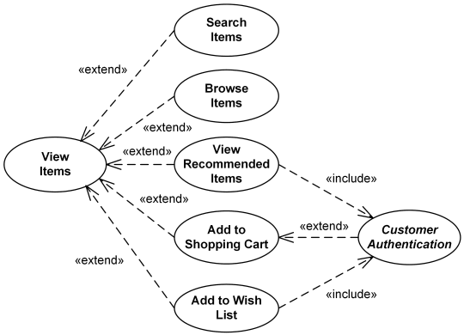
Figure 3: View items for Aquas

Checkout use case includes several required uses cases. Web customer should be authenticated. It could be done through user login page, user authentication cookie ("Remember me") or Single Sign-On (SSO). Web site authentication service is used in all these use cases, while SSO also requires participation of external identity provider.

Checkout use case also includes Payment use case which is done as cash on delivery. 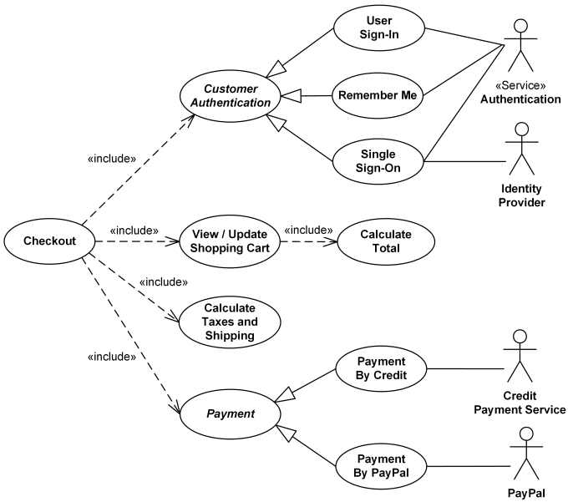

Figure 4: Checkout for Aquas
Two actors using administrative interfaces are Website Administrator and Help Desk. Help Desk uses a subset of functions available to the Website Administrator. All top level use cases shown are abstract as each represents some group or "package" of administrative functionality.

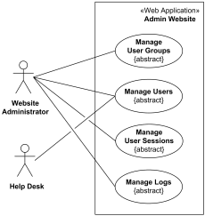

Website Administrator actor could manage user groups, users, user sessions, and logs. Help Desk staff uses a subset of functions available to the Website Administrator.

User Manual for each Use case
The use cases associated in this project are:
- Registration
- View items
- Make purchase
- Checkout

Registration:
Through the Aquas website the customer or the user registers and using the email and password through which he registers he/she can login. After logging in, the user can request for services like Fishes, Aquariums, Fish Food, Care, Lights, Service. The website use case includes other use case View Items mainly displays the items that are available in the website. User must register and login first to place order if he is not logged in then the website asks him to login to place order.
Register

Figure 5: Use case for registration

View Items:
The user can be viewed items even when he is not logged in but to place order he has to login and select items like Aquariums, Fishes, Fish Food, Care, lights and Service. The user must add items to the cart to make purchase. User can add any number of items from any category and can add each items quantity. The user must select each item, give details and place order. The order will be delivered in two or three days.
Select items
View items

Figure 6: Use case for View Items

Make Purchase:
The use case Make Purchase helps in purchasing the selected items. Through Make Purchase the registered user can place order whatever products he wanted to buy. The user views the items in the items list and add items to the cart and he fills in all the details in the form to whom the product must be delivered.
Make Purchase
Place Order

Figure 7: use case for make purchase.

Checkout:
The use case Checkout helps in place order from the items. The user selects the items and adds them to cart. After adding to the Cart, the user must check which items has to be placed order. He must fill all the details in the form like Name, Email, Phone and Address. After placing the order, the user will be given a success message as the order has been placed.
Place order

Figure 8: use case for checkout

4.Implementations
4.1 Source code structure
4.1.1 Folders:

- CSS
- Java script
- Assets

CSS:
It is the folder that contains all “.CSS”files that are created to provide styling to the website.
Java script:
It contains all the .js files.
Assets:
It contains all the source files.

4.1.2 Files:
- Registration.php
- Login.php
- Home.php
- Fishes.php
- Aquariums.php
- Food.php
- Care.php
- Lights.php
- Testbag.php
- Service.php
Parameters, Functions and flow chart for each file:

Registration Page

Flow Chart:
Go back to register page
Register
Confirm Password
Enter Password
Enter Email

Enter Name
start

Yes No
Success?

Go to log in page
Display error message

Stop

Figure 9: Flow Chart for Registration Page
Parameters:

The parameters in registration page are:

- First Name
- Email
- Enter Password
- Confirm Password

Function:
On entering the registration page, the user is expected to enter User Name without special characters. He/She is expected to enter the Email id and the password. Failing the conditions does not create an account for the user and the page is reloaded with the unsuccessful message. If the account creation is successful, the user is redirected to log in page.

Login Page
Parameters:
The parameters in registration page are:
- User Name
- Enter Password

Function:
On entering the login page, the user is expected to enter his User Name and Password. If all the details are correct, then the user is redirected to his profile.
If the mentioned are wrong, the log in page is reloaded and the user is displayed “Invalid Credentials. Try Again.” Message.

Flow Chart:

Go to login page
Display error message
Go back to register page
Register
Confirm Password
Enter Password
Enter Email

Enter Name
start

Yes No
Success?

Stop
---++

Figure 10: Flow Chart for Log in Page

Home Page
Flowchart:
Start
Login to place order
Go to Home to return home
Go to Contact to know our details
Go to About us to know about website
Go to Products to Search for items

Stop

Figure 11: Flow Chart for Home Page

Parameters:
The parameters in registration page are:
- Profile Details
- Products
- About us
- Contact
- Cart

Functions:

After successful log in, the user is redirected to his profile. The user name is stored in a session variable from the log in page and is used here to display his user name
List of products are displayed for selection purpose. About us displays the Website details, Contact displays the Admin details and the developers. Cart displays the selected items from where they can check out.

Fishes Page

Parameters:

- Searching
- Selecting
- Enter the Quantity
- Add to cart
- Place order

Functions:

Under the product section select the fishes where there are different breeds for the customers to search and select. The quantity can be mentioned and then the product is added to cart and order is placed.

Flowchart:
Start
Go to cart to place order
Add to cart
Enter quantity
Select fishes
Search for different fishes

Stop

Figure 12: Flow Chart for Fishes

Aquariums Page

Flow chart:
Start
Go to cart to place order
Add to cart
Enter quantity
Select aquarium
Search for different aquariums

Stop

Figure 13: Flow Chart for Aquariums

Parameters:

- Searching
- Selecting
- Enter the Quantity
- Add to cart
- Place order

Function:

Under the product section select the Aquariums where there are different Aquarium tanks and models are displayed for the customers to search and select. The quantity can be mentioned and then the product is added to cart and order is placed.

Fish Food Page:
Parameters:
- Searching
- Selecting
- Enter the Quantity
- Add to cart
- Place order

Function:
Under the product section select the Fish food where there are different Brand and quality of fish food displayed for the customers to search and select. The quantity can be mentioned and then the product is added to cart and order is placed.

Flow chart:
Start
Go to cart to place order
Add to cart
Enter quantity
Select item
Search food for fishes

Stop

Figure 14: Flow Chart for Fish Food

Care and Treatment
Flow chart:

Start
Go to cart to place order
Add to cart
Enter quantity
Select treatment
Search for care

Stop

Figure 15: Flow Chart for Care and treatment
Parameters:
- Searching
- Selecting
- Enter the Quantity
- Add to cart
- Place order

Functions:
Under the product section select the Care and Treatment where there are different Brand and quality of products such as Fish bacteria care and fungal care are displayed for the customers to search and select. The quantity can be mentioned and then the product is added to cart and order is placed.

Lights and Heaters
Parameters:
- Searching
- Selecting
- Enter the Quantity
- Add to cart
- Place order

Function:
Under the product section select the Lights and Heaters where there are different Brand and quality of products such as Aquarium lamps, heaters are displayed for the customers to search and select. The quantity can be mentioned and then the product is added to cart and order is placed.

Flow chart:
Start
Go to cart to place order
Add to cart
Enter quantity
Select item
Search for different lights and heaters

Stop

Figure 16: Flow chart for Lights and Heaters

Cart Page
Flow chart:
Start
Place Order
Enter Delivery Address
Enter Phone Number
Enter Email
Enter Name

Stop

Figure 17: Flow Chart for Cart

Parameters:

The parameters in registration page are:

- Name
- Email
- Phone number
- Delivery address
- Place order

Function:
On entering the Cart, the user is expected to enter User Name without special characters. He/She is expected to enter the Email id and the Phone number. Delivery address should be provided correctly for delivery and lastly placing the order.

Profile page
Parameters:
- Retrieve username
- Display username
- home page
- Logout

Function:
The profile page displays the user name and the redirection to the home page is possible the user details are mentioned in this page. The logout option is given in this page which logs out the use from the website.

Flow chart:
Start
Display username after login
Retrieve username from login page

Display home page as logged in page

Select logout to logout from your account

Goes back to home page

Stop

Figure 18: Flow chart for profile page

Service page:
Flow chart:
Start
Enter Email
Enter Name

Enter Phone

Enter Address

Enter Problem

Submit

Stop

Figure 19: Flow Chart for service page
Parameters:
- Name
- Email
- Phone
- Address
- Problem

Function:
On entering the service page user must enter the problem for which he is requesting the service along with the name, email, phone, address. On entering the request, the request will be placed, and success message will appear.

Admin page:
Parameters:
- Orders
- Services
- Add or Remove Products
- Manage accounts

Function:
Admin is the only one who can access this page. In this we display all the orders and services that are placed by the user.

Flow chart:
Start
Display orders
Retrieve orders from database

Retrieve services from database

Display service request

logout

Stop

Figure 20: Flow chart for admin page

5.Database Design
In this project of Aquas, the database has tables namely:
- Registration(rs)
- tbl_product
- food
- aquariums
- Care
- lights
- placed_order
- confirmed_cards
- service
Registration (user_name, email, password):
For registration table we have attributes: user_name varchar(20), email varchar(50),password varchar(20), It is illustrated in table1
For example:
In this table, the user name is the primary key and holds unique for every customer. Whatever details, the customer enters, those details are stored in this registration table. We can see the glimpse of the table from the database:

Attribute | Type
user_name | varchar(20)
email | varchar(50)
password | varchar(20)
Table1: Customer Table.
password

email
Registration

user_name

Figure 21: Registration table and attributes

tbl_product (id, name, image, price):
`id` int(100) NOT NULL,
`name` varchar(100) NOT NULL,
`image` varchar(20) NOT NULL,
`price` varchar(100) NOT NULL

Attribute | Type
Id | int(100)
name | varchar(100)
image | varchar(20)
price | varchar(100)
Table 2: tbl_product Table.
id

image
name
tbl_product

price

Figure 22: tbl_product table and attributes

Food (id, name, image, price):

`id` int(100) NOT NULL,

`name` varchar(100) NOT NULL,

`image` varchar(50) NOT NULL,

`price` int(100) NOT NULL

Attribute | Type
id | int(100)
name | varchar(100)
image | varchar(20)
price | varchar(100)

Table 3: Food Table

Id

image
name
Food

price

Figure 23: Food table and attributes

Aquariums (id, name, image, price):

`id` int(100) NOT NULL,

`name` varchar(100) NOT NULL,

`image` varchar(50) NOT NULL,

`price` int(100) NOT NULL

Attribute | Type
Id | int(100)
Name | varchar(100)
Image | varchar(20)
Price | varchar(100)

Table 4: Aquariums Table
id

image
name
Aquariums

price

Figure 24: Aquariums table and attributes

Care (id, name, image, price):

`id` int(100) NOT NULL,

`name` varchar (100) NOT NULL,

`image` varchar (50) NOT NULL,

`price` int(100) NOT NULL

Attribute | Type
id | Int (100)
name | Varchar (100)
image | varchar (20)
price | varchar (100)

Table 5: Care Table

id

image
name
Care

price

Figure 25: Care table and attributes

Lights (id, name, image, price):

`id` int (100) NOT NULL,

`name` varchar (100) NOT NULL,

`image` varchar (50) NOT NULL,

`price` int (100) NOT NULL

Attribute | Type
id | Int (100)
name | Varchar (100)
image | Varchar (20)
price | Varchar (100)

Table 6: Lights Table

Id

image
name
Lights

price

Figure 26: Lights table and attributes

Placed_order (id, item_name, quantity, price, name, email, phone, address):
`id` int (11) NOT NULL,

`item_name` text NOT NULL,

`quantity` text NOT NULL,

`price` text NOT NULL,

`name` text NOT NULL,

`email` text NOT NULL,

`phone` text NOT NULL,

`address` text NOT NULL

Attribute | Type
id | int(20)
Item_name | text
quantity | int(20)
price | varchar(20)
name | text
email | Varchar(20)
phone | varchar(20)
address | text
Table 7: Placed_order table

item_name
id
quantity
email
Name
Address
phone
price
Placed_order

Figure 27: Placed_order and attributes
Confirmed_cards(customer, cust_email, id, name, price, quantity):
`customer` text NOT NULL,

`cust_email` text NOT NULL,

`id` int (11) NOT NULL,

`item_name` text NOT NULL,

`quantity` text NOT NULL,

`price` text NOT NULL,

Attribute | Type
customer | text
cust_email | text
id | text
name | text
price | text
quantity | text

Table 8: confirmed_cards table

Id
Cust_email
Customer

Confirmed_cards

Name
Quantity
Price

Figure 28: confirmed_cards and attributes

Service (name, email, phone, address, problem):
`name` text NOT NULL,

`email` text NOT NULL,

`phone` text NOT NULL,

`address` text NOT NULL

`problem` text NOT NULL

Attribute | Type
name | text
email | text
phone | text
address | text
problem | text

Table 9: Service table

phone
email
name

Service

address
problem

Figure 29: service and attributes

6.Test Cases

Introduction:

A test case is a software testing document, which consists of event, action, input, output, expected result and actual result. Test case defined as test case is an input and an expected result. It can occasionally be a series of steps
Test cases in the project:
Test case id | Test Case | Function being tested | Initial State | Input | Output | Status
1 | Register | Accept Details | Home Page | Enter Details | Registration Successful | Successful
2 | Login | Verify Username and password | Home Page | Enter Details | Home Page | Successful
3 | Search Product | Searching Product and Selecting options | Products page | Selecting  product | Cart page | Successful
4 | Services | Accept details | Home page | Enter details | Service provider contacted | Successful
5 | Place Order | Placing the order | Cart page | Selecting products and enter details | Mail_handler page | Successful

7.Screen Shots
Home Page:
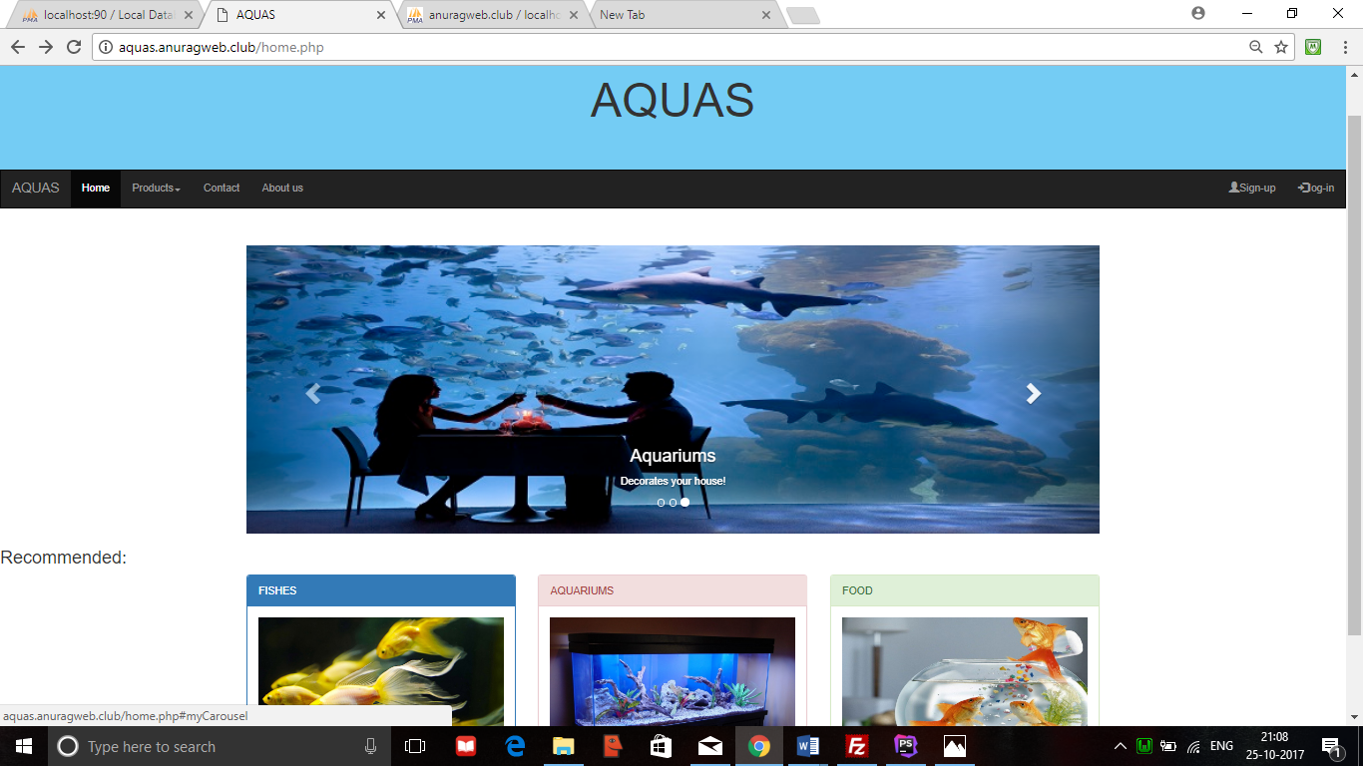

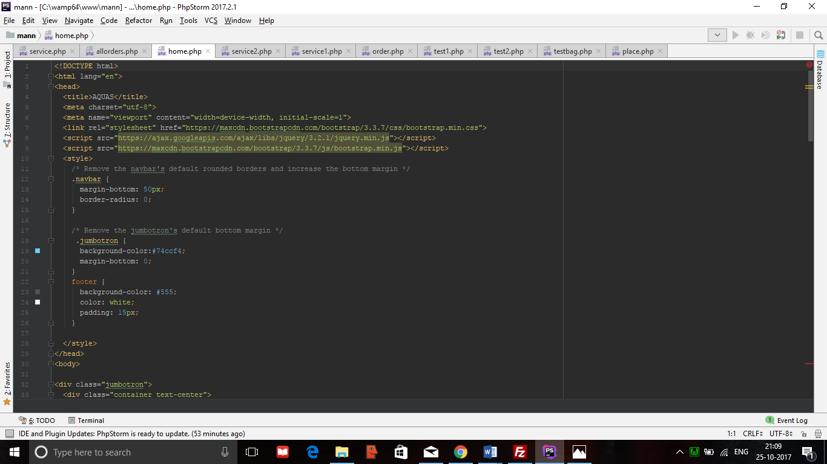
Registration Page:
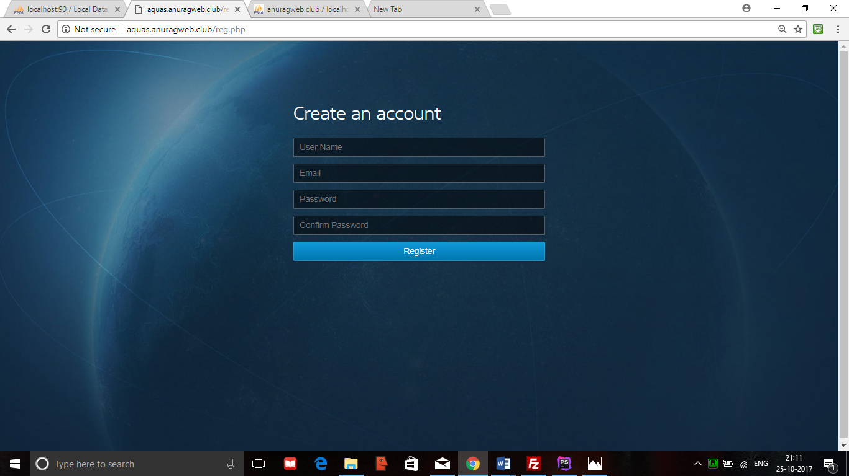

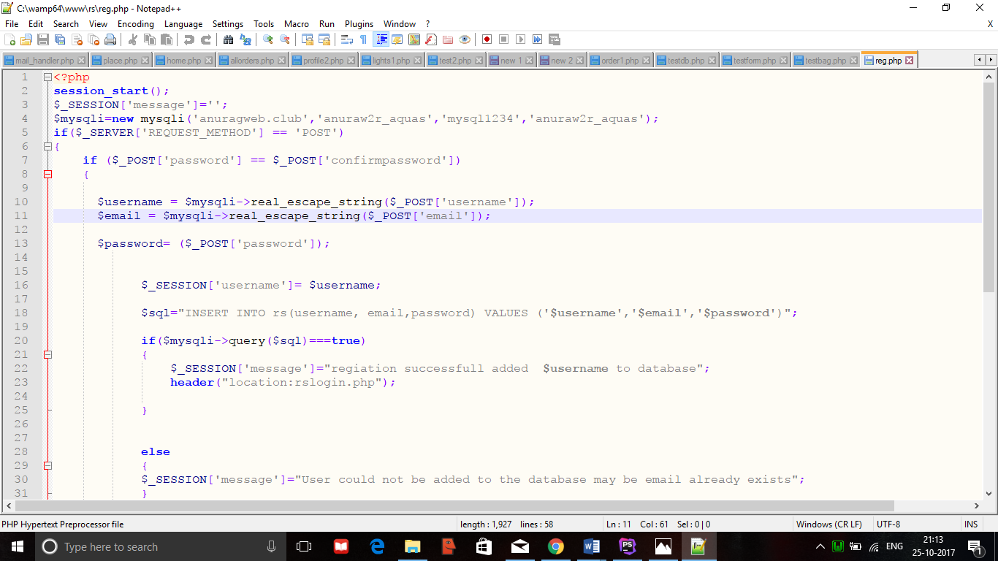
Login Page:
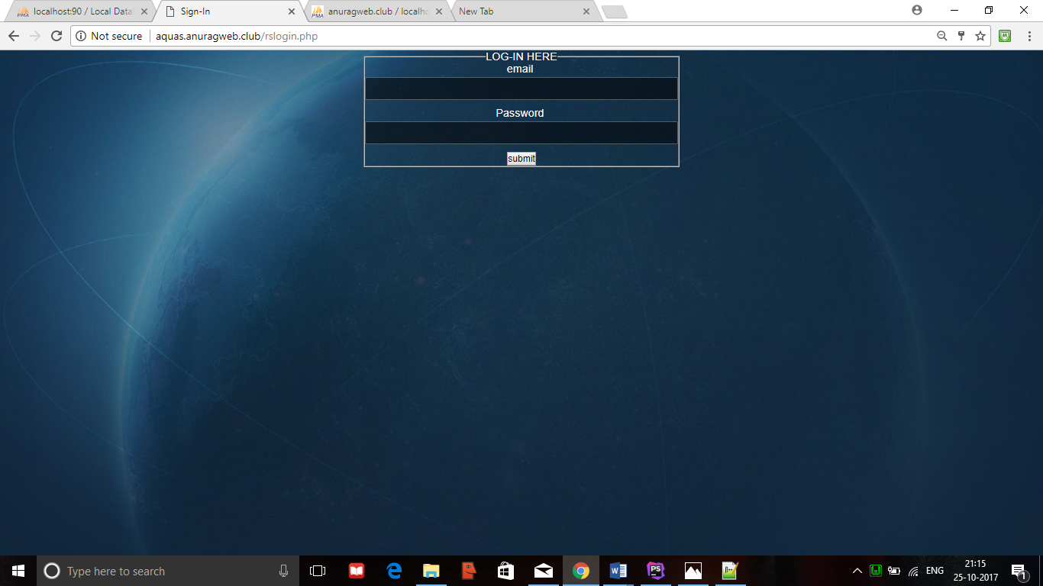

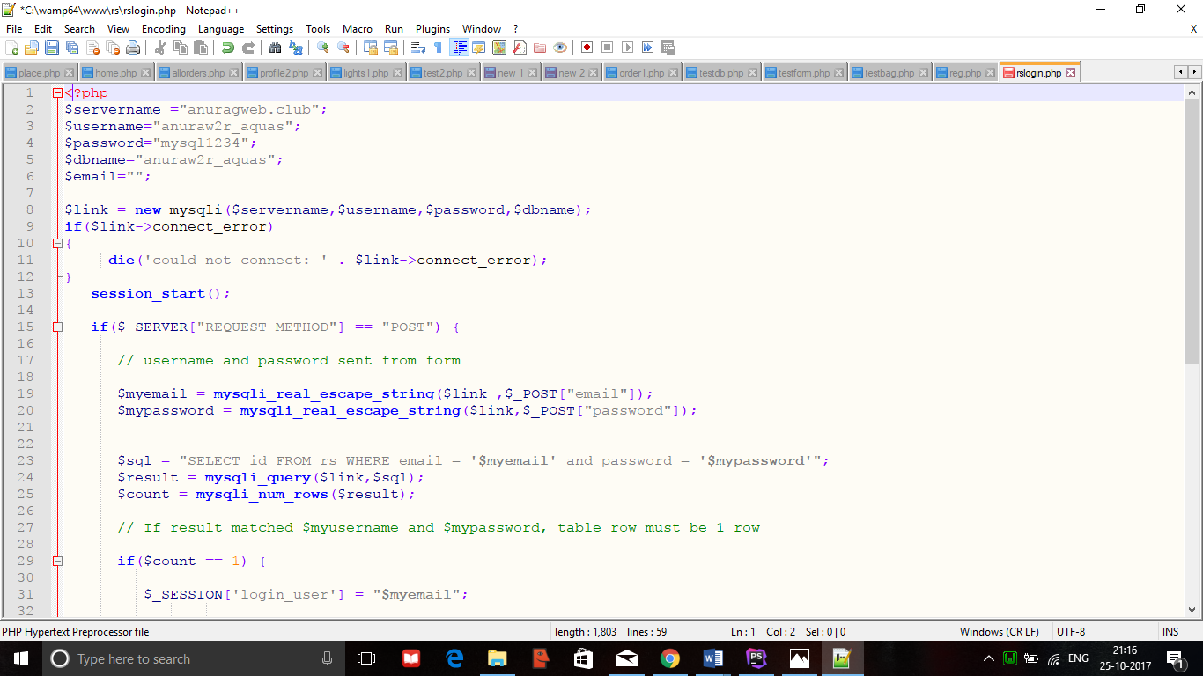

Products Page:
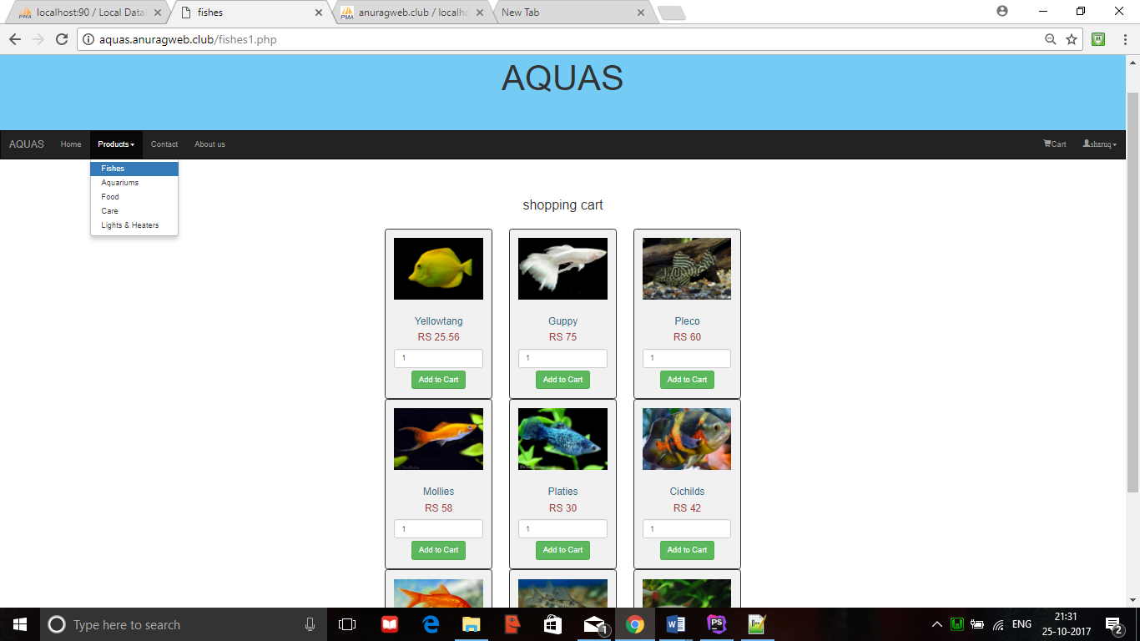

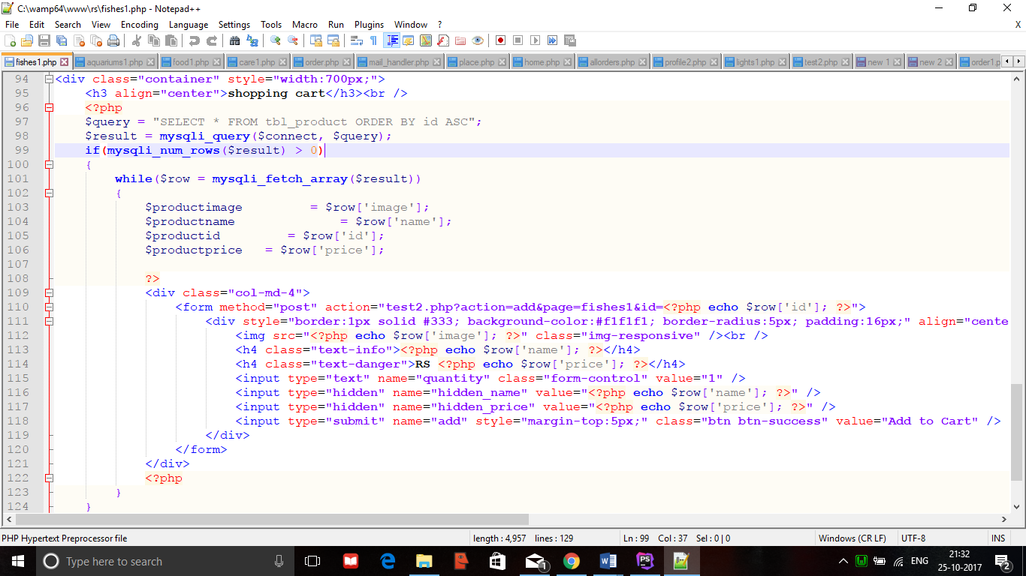

Cart Page:
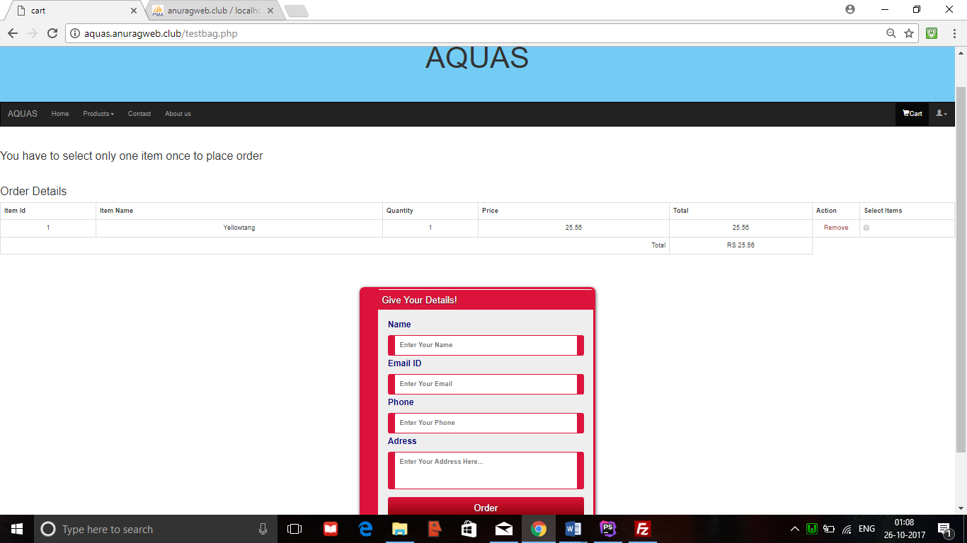

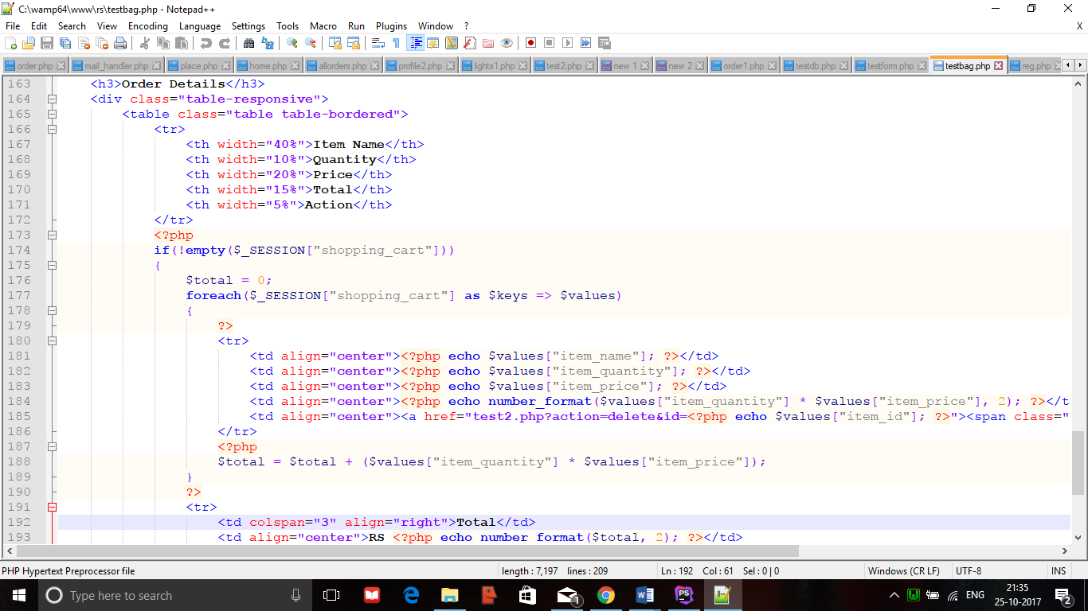

Service Page:
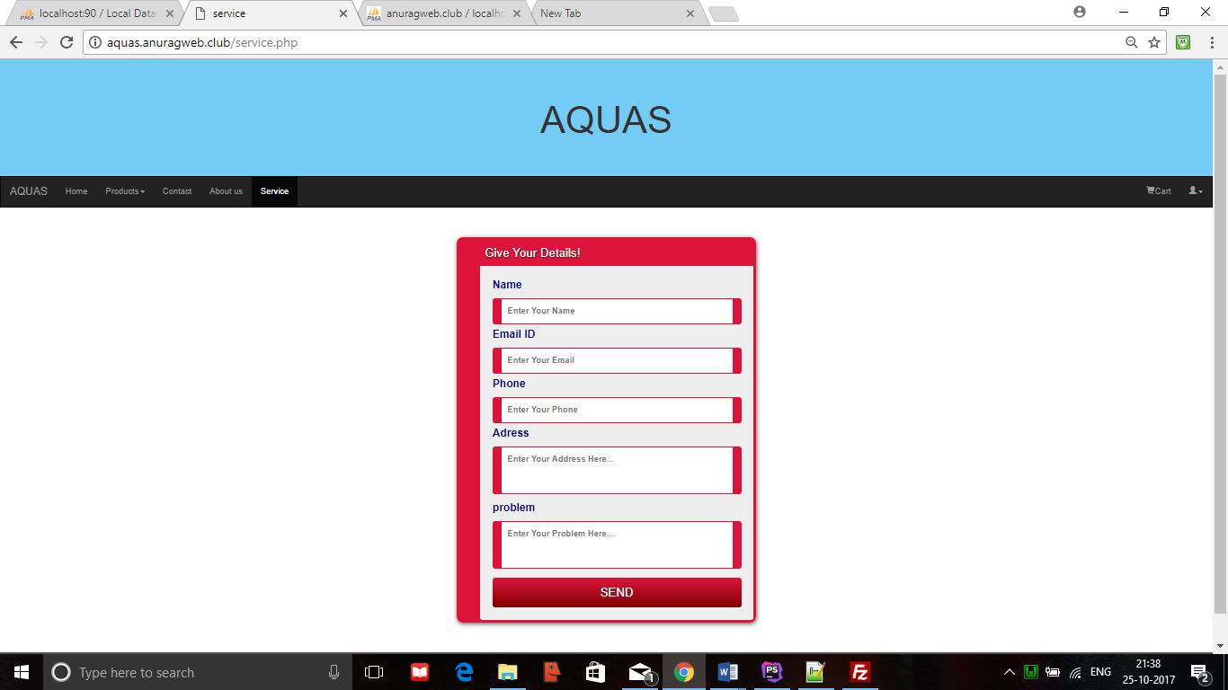

Database:
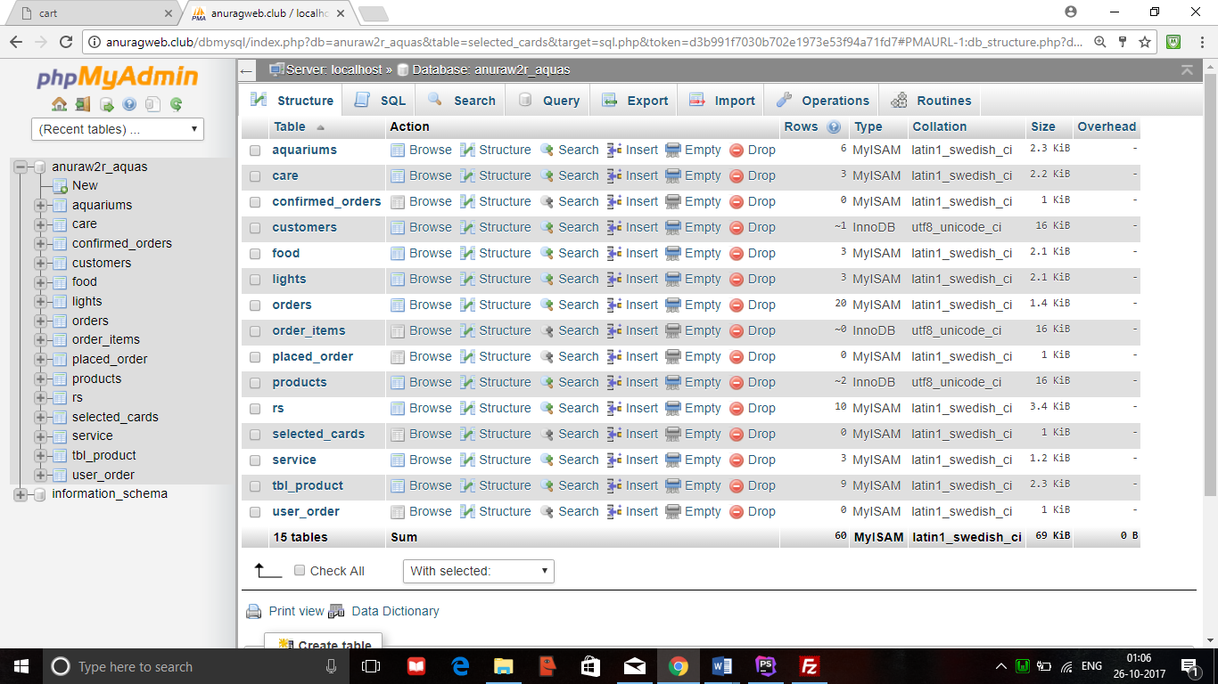
7. Deployment Diagram
The figure32 shows the deployment diagram of Aquas. The nodes are:
Aquas:
This node performs following functions:
1.Registration: Allows the user to register.

2.Login: For user log in.

3.Service: To request the service (Doorstep)

4.Admin: To view the services.

5.Cart: The desired products are added to the cart for placing the order.

6.Place order: The delivery address is mentioned, and delivery is done.

Registration:
The function is:
- Add User: User Registration. To add a new user to Aquas. It requires a component user.

- User Identification: It gives an identification to the user with which he can access the website.

Login:
The functions are:
- Account Access: To login and access the account.

- Register Service: To request the service (Doorstep).

Admin:
The functions are:
1.Check Services: To view the services (Doorstep and Problems) and check status.

2.Check Orders: To view the orders and check status.

3.Adding or Removing products: The products are added and removed into the website

Services:
This node is associated with a component mechanic. This node functions are:
1.Fishes: Different kinds of fishes.

2.Aquariums: Different kinds of aquariums.

3.Food: Different kinds of fish food.

4.Care: Different kinds of treatment kits.

5.Lights: Different kinds of lights and heaters.

6.Service: Maintenance is provided to your doorsteps.

Deployment Diagram:

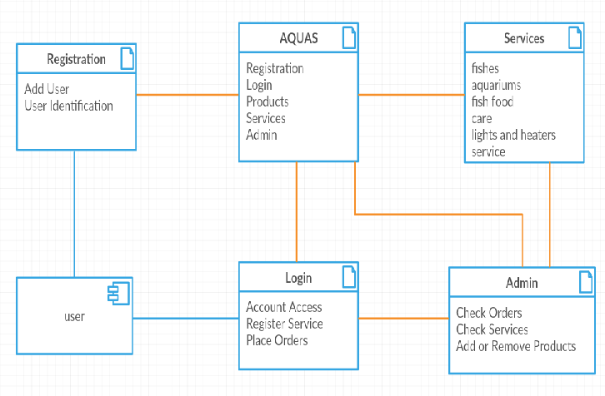
Figure 30: Deployment diagram for Aquas

8. Conclusion

Hence, this website is designed to help the Customers by providing the home delivery for the products which are fragile. The users who may not find the time to service the Aquarium tanks can register through our website for services. This website is a great help for those who face problem with transporting the heavy goods and with the fishes which easily die. The user will get the product home delivered safely without any damage This website provides easy delivery and easy services to be accessed. Admin plays the key role in monitoring everything.

